Hello «first_name» «last_name_»,

Enclosed you will receive your login data for the employee app.

When you log in the first time, you will be asked to enter a new password.

If you have any questions or suggestions, please feel free to contact your administrator.

We hope you enjoy using your employee app.

Your Flip Team!

**How you get to your Employee App:**

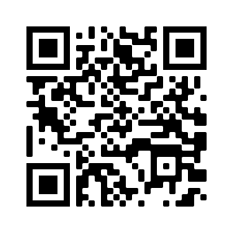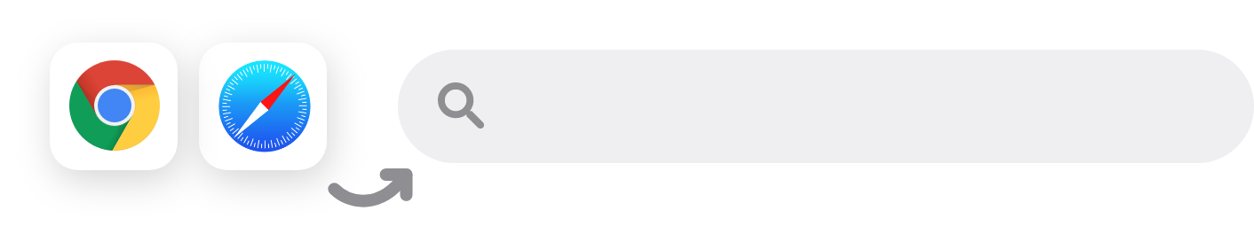

Enter the URL in your browser or scan the QR code for iOS on the right side:

or

«URL»

QR- Code der Landing Page tauschen

**Your login data:**

Username:

Password:

«username_»

«password»

Instructions on the backside



**Apple**

Open the **Safari Browser** on your smartphone and enter the address

**«URL»** or scan the **QR code** on the front page.

Download the **„Flip Employee App“** via the **Load Button**.

After that, open the **„«app_name_short»“** and enter the company URL

**«URL»** in the pop-up window,

if necessary.

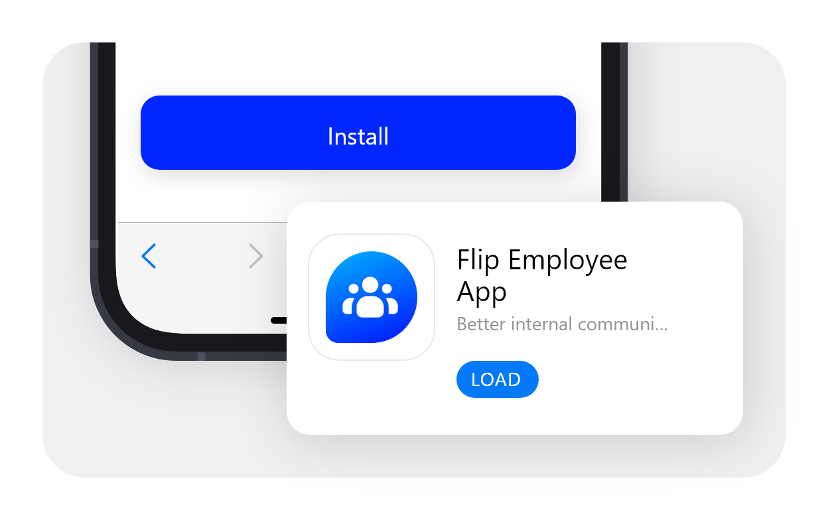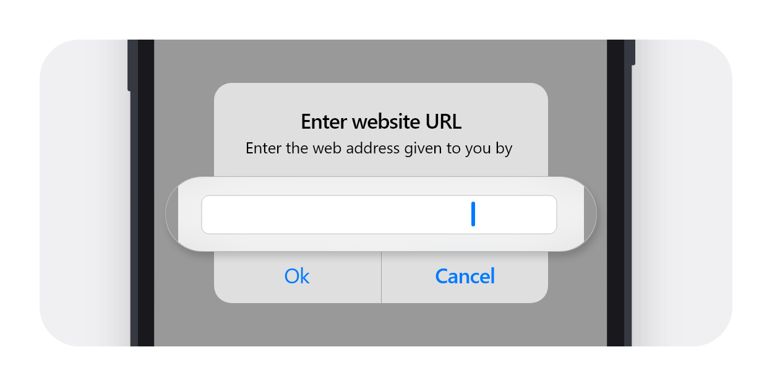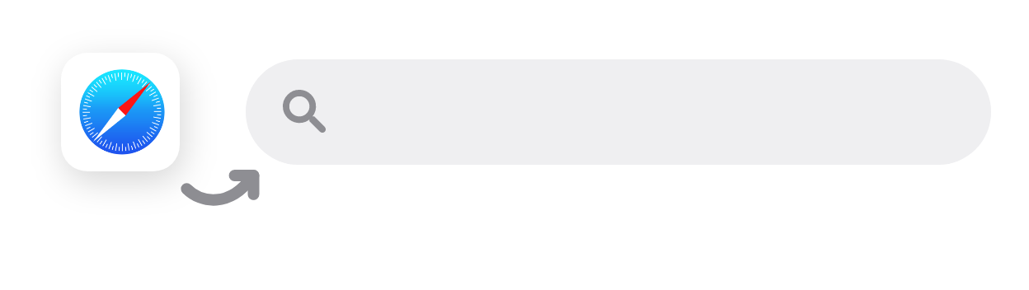

«URL»

«URL»

**Installation Guide for your Employee App**

Installationsanleitung für Ihre Mitarbeiter-App

«URL»

Open the **Google Chrome Browser** on your smartphone and enter the address **«URL»** or scan the **QR code** on the front page.

Download the **„«app_name_short» “** via the **Install Button**. After that, open the app on your home screen.

**Android**

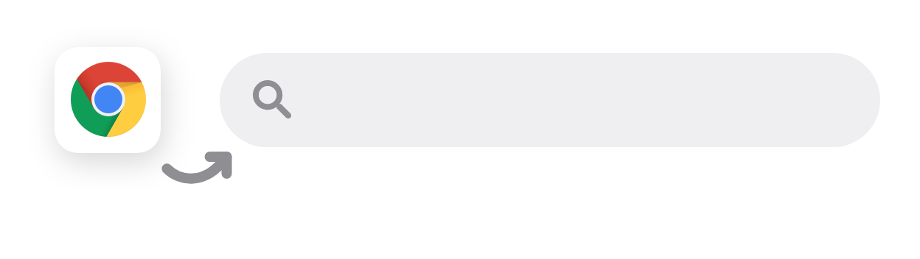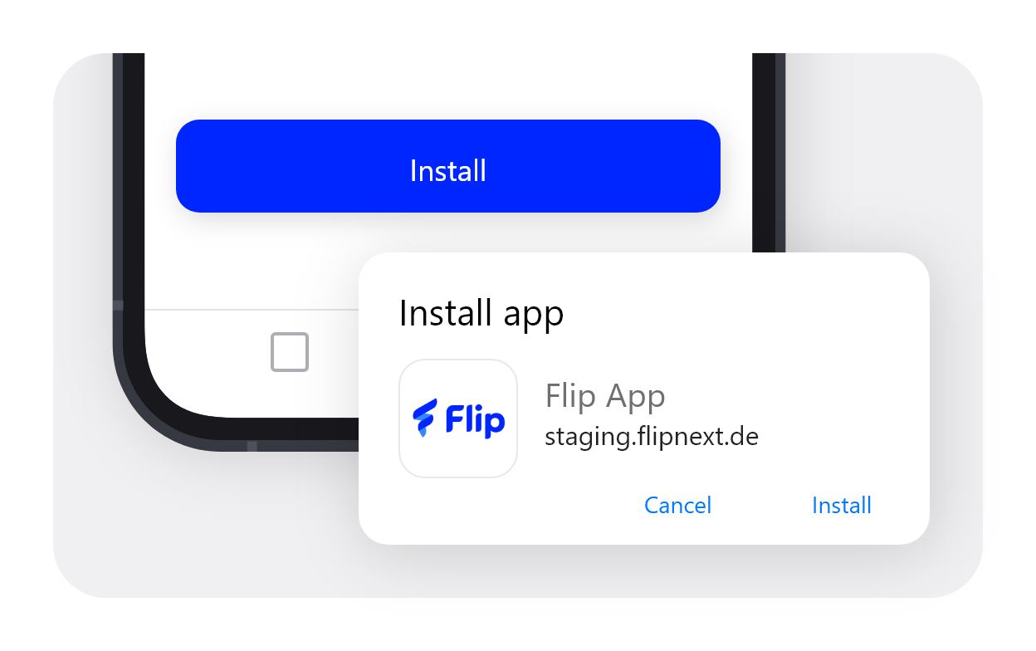

«URL»

**Desktop**

Open the **Google Chrome** or

**Microsoft Edge Browser** on your PC and enter the address **«URL»**.

Download the **„«app_name_long»“** via the **Install Button.**

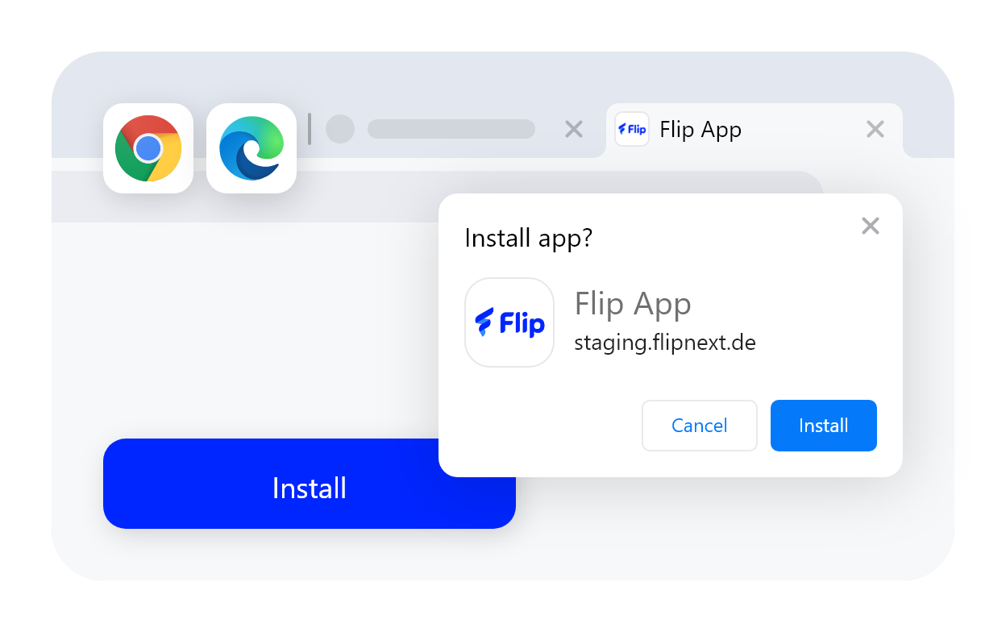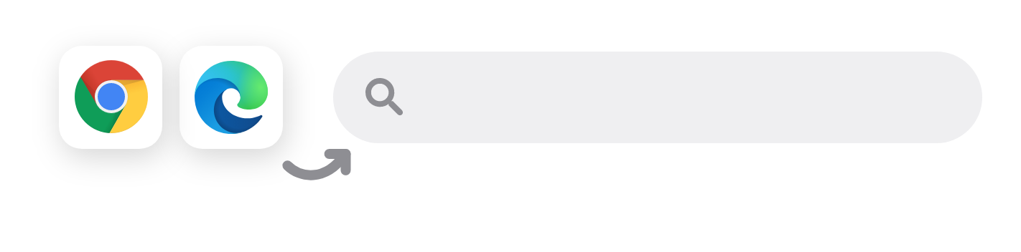

«URL»